**Experiment 32**

**Lab Book:**

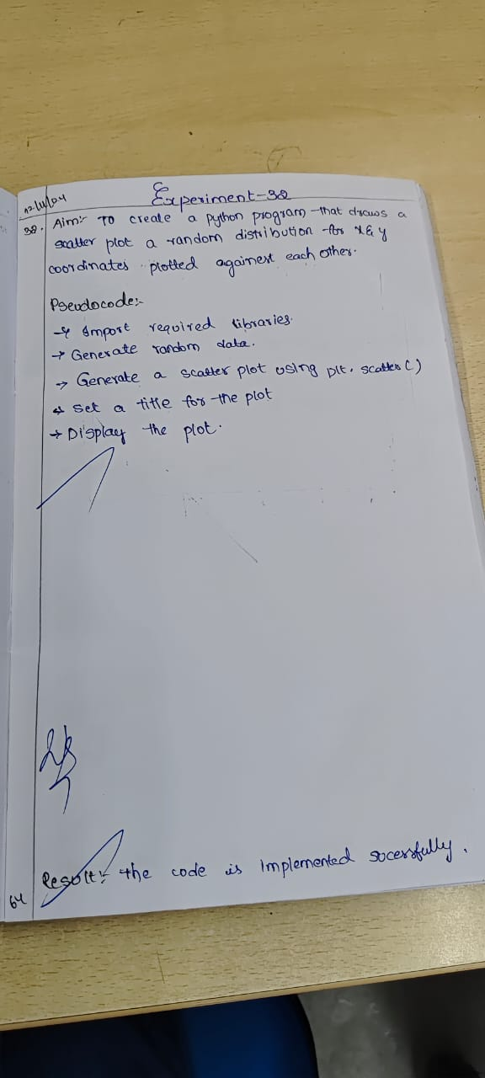

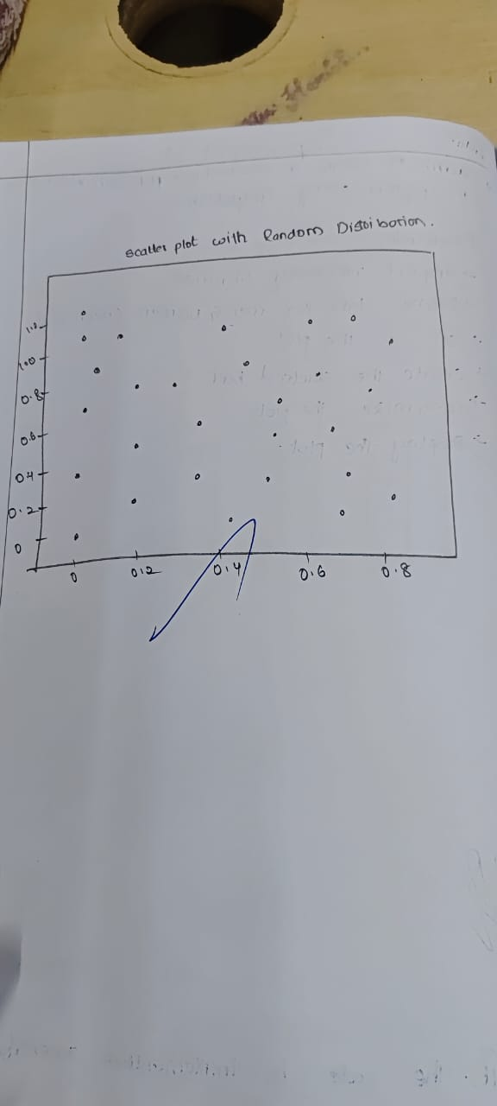

**Code**

import matplotlib.pyplot as plt

import numpy as np

x = np.random.rand(50)

y = np.random.rand(50)

plt.scatter(x, y, color='b')

plt.title('Scatter graph with Random Distribution')

plt.show()

**Sample Output**

